Honors Algebra 2

Midterm Review

Algebra 2 Midterm Review
Chapter 1 Review
50 Questions on the Midterm Exam

Graph the function and identify the function, then describe the transformations of functions.
1. $f\left(x\right)=x+3$ 2. $h\left(x\right)=\frac{1}{2}x^{2}$ 3. $f\left(x\right)=-\left|x\right|-3$

4. Write a function g that is a translation 4 units right and 6 units down, followed by a reflection about the x-axis of the graph of $f\left(x\right)=-\frac{1}{2}{\left(x+1\right)}^{2}$.

Write a function g whose graph represents the indicated transformations of the graph of f for #5-8.

5. $f\left(x\right)=x$; vertical stretch by a factor of 3.

6. $f\left(x\right)=-3x+4$; translation 3 units down followed by a reflection about the x-axis.

7. $f\left(x\right)=2\left|x\right|-9$; translation 2 units left and 6 units up followed by a vertical shrink by a factor of $\frac{1}{3}$.

8. $f\left(x\right)=\frac{1}{2}{\left(x+2\right)}^{2}-5$; vertical stretch by a factor of 2 followed by a translation of 4 units right.

9. The total cost of an annual pass for admission to a national park plus camping for x days can be modeled by the function $f\left(x\right)=20x+80$. A senior citizen pays $20 less than half of this price for x days. What is the total cost for a senior citizen to go camping for three days in the park?

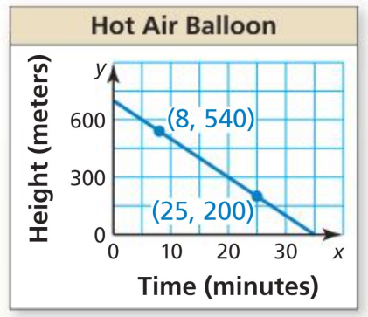
10. Use the graph to write an equation of the line and interpret the slope.

Write the linear equation in slope-intercept form for each given set of information for #11-13.
$$x$$ | $$y$$
-4 | 2
-1 | 1
2 | 0
5 | -1
11. $m=\frac{2}{3}$, $\left(3,6\right)$ 12. $\left(-2,5\right), (-1,1)$ 13.

14. The table shows the numbers of ice cream cones sold for different outside temperatures (in degrees Fahrenheit). Do the data show a linear relationship? If so, write an equation of a line of fit and use it to estimate how many ice cream cones are sold when the temperature is 60°F.
Temperature, x | 53 | 62 | 70 | 82 | 90
Number of cones, y | 90 | 105 | 117 | 131 | 147

Solve the system of equations.
15. $\left\{\begin{aligned}-4x-8y=-24 \\ 3x+2y=10\end{aligned}\right.$ 16. $\left\{\begin{aligned}y=\frac{1}{2}x+3 \\ -x+2y=-2\end{aligned}\right.$

17. $\left\{\begin{aligned}x+y+z=3 \\ -x+3y+2z=-8 \\ x=4z\end{aligned}\right.$ 18. $\left\{\begin{aligned}x+2y-2z=10 \\ -2x+y+2z=-9 \\ 3x-4y+4z=-10\end{aligned}\right.$

Chapter 2 Review
Describe the transformation of $f\left(x\right)=x^{2}$ represented by g. Then graph each function.
19. $g\left(x\right)=-\frac{1}{5}x^{2}$ 20. $g\left(x\right)=-3{\left(x+2\right)}^{2}-1$

Write a rule for g.

21. The graph of g is a vertical stretch by a factor of 3, followed by a translation 5 units right of the graph $f\left(x\right)=x^{2}$.

22.The graph of g is a translation 2 units left and 3 units up, followed by a refection about the x-axis of the graph $f\left(x\right)=x^{2}-2x$.

23. The graph represents the path of a football kicked by a player, where $x$ is the horizontal distance (in yards) and $y$ is the height (in yards). The player kicks the ball a second time so that it travels the same horizontal distance, but reaches a maximum height that is 6 yards greater than the maximum height of the first kick. Write a function that models the path of the second kick.
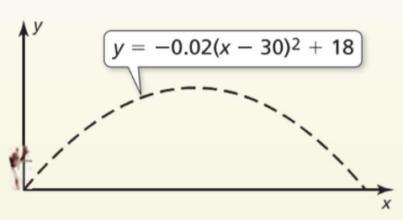
Graph the function. Label the vertex and axis of symmetry. Find the minimum value or maximum value of the function. Find when the function is increasing and decreasing.
24. $f\left(x\right)=3{\left(x-1\right)}^{2}-4$ 25. $h\left(x\right)=\left(x-3\right)\left(x+7\right)$
Vertex: ______________ AS: _____________
Min or Max: ___________________________
Inc.: ______________ Dec.: ______________
Vertex: ______________ AS: _____________
Min or Max: ___________________________
Inc.: ______________ Dec.: ______________

26. Write a quadratic function in standard form with a vertex of (3,2) and $y$-intercept of 20.

Write the equation of the parabola with the given characteristics.

27. passes through (-2,3), and has a vertex of (-4,7)
28. Passes through (4,3) and has x-intercepts -1 and 5

29. passes through (-2,29), (1,-4), and (4,17)

30. The table shows the average total stopping distances of a vehicle on dry pavement at different speeds.
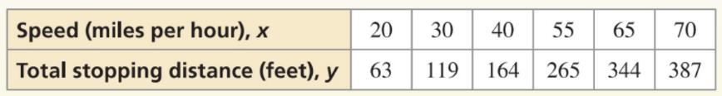
- Write the function that models the data.
- Estimate the total stopping distance of a vehicle traveling 45 miles per hour.

Chapter 2.5 Review
Factor completely. If the polynomial is not factorable, write prime.
31. $x^{2}+10x-39$ 32. $x^{2}-16$ 33. $8x^{3}+27$

34. $18x^{3}+3x^{2}-3x$ 35. $x^{2}+16x+64$ 36. $9x^{2}-30x+16$

37. $25x^{2}+36$ 38. $25x^{4}-10x^{3}-5x+2$ 39. $4x^{2}+13x-12$

40. $x^{2}-12x-28$ 41. $-8x^{2}+6x+5$ 42. $x^{3}-1$

Chapter 3 Review
Solve the equation using any method.
43. $2x^{2}-17x=30$ 44. $2{\left(x+2\right)}^{2}-5=8$ 45. $x^{2}+17x+16=0$

46. $2x^{2}+5x=3$ 47. $3x^{2}-12x+13=0$ 48. ${\left(x-4\right)}^{2}=49$

Find the zeros.
49. $f\left(x\right)=3x^{2}-6x+3$ 50. $h\left(x\right)=3x^{2}-12$ 51. $g\left(x\right)=x^{2}-2x+2$

Perform the operation. Write the answer in standard form.
52. $\left(9+3ⅈ\right)-\left(-2-7ⅈ\right)$ 53. $\left(8+2ⅈ\right)\left(8-2ⅈ\right)$ 54. $\left(10-ⅈ\right)+\left(6+4ⅈ\right)$

55. $\left(2+ⅈ\right)\left(5-3ⅈ\right)$ 56. ${\left(1+2ⅈ\right)}^{2}$ 57. $\left(-2+3ⅈ\right)-\left(4+ⅈ\right)$

58. Dustin Johnson hits a golf ball and the height of the ball, h, in feet, after t seconds, obeys the equation
$h=-16t^{2}+88t+0.25$.
a. What is the initial height of the ball? Does this make sense?
b. At what time does the ball reach its maximum height? What is the maximum height of the ball?
c. When does the ball hit the ground?

59. You kick a kickball. The path of the ball is represented by $y=x(0.6-0.02x)$, where x is the horizontal distance (in feet) and y is the corresponding height (in feet). Your second kick reaches a maximum height of 7 feet, 12 feet away from you.
a. Which kick travels higher?
b. Which kick travels farther before hitting the ground?

Solve the system by any method.
60. $\left\{\begin{aligned}x^{2}-6x+13=y \\ y=2x-3\end{aligned}\right.$ 61. $\left\{\begin{aligned}2x-3=y+5x^{2} \\ y=-3x-3\end{aligned}\right.$ 62. $\left\{\begin{aligned}x^{2}+y^{2}=5 \\ -x+y=-1\end{aligned}\right.$

63. $\left\{\begin{aligned}{-3x}^{2}+2x-5=y \\ -x+2=-y\end{aligned}\right.$ 64. $\left\{\begin{aligned}y=-x^{2}-6x-10 \\ y=3x^{2}+18x+22\end{aligned}\right.$ 65. $\left\{\begin{aligned}y=0.5x^{2}-10 \\ y=-x^{2}+14\end{aligned}\right.$

Graph the inequality.
66. $y>x^{2}+8x+16$ 67. $x^{2}+y≤7x-12$
Graph the system of inequalities.
68. $\left\{\begin{aligned}y≥x^{2}-4 \\ y≤-2x^{2}+7x+4\end{aligned}\right.$ 69. $\left\{\begin{aligned}y≥x^{2}-3x-6 \\ y≤x^{2}+7x+6\end{aligned}\right.$
Solve the inequality.
70. $-x^{2}-10x<21$ 71. $x^{2}+10x+9<0$ 72. $4x^{2}+8x-21≥0$

